**A Comprehensive Study on Wind Turbine, Solar Roof, and Car Integration for Electric Car Production**

Author : Kondwani Nyirenda, Praise Mwanza,Affiliation: The Copperbelt University school of Engineering, Dr. Robot General Dealers, Email: [kondwaninyirenda99@gmail.com](mailto:kondwaninyirenda99@gmail.com), [praisemwanza52@gmail.com](mailto:praisemwanza52@gmail.com)

**ABSTRACT**

This article presents a comprehensive study on the integration of wind turbines ,solar roofs, and cars to achieve sustainable electrical production. The aim is to explore the engineering principles and methodologies required for the successful implementation of such an integrated system. The article provides an overview of the current advancements in renewable energy. Furthermore ,it delves into the technical aspects ,design considerations, and optimization strategies for the seamless integration of wind turbines,solar roofs,and cars into a unified electrical production system. The findings of this study can serve as valuable reference for engineer sand researchers involved in the field of sustainable energy production.

**Keywords:** wind turbines ,solar panels, electrical production (Generation)

**INTRODUCTION**

Wind turbines are a highly efficient means of converting wind energy into electricity. Their efficiency is typically measured by a metric called "capacity factor," which represents the actual output of a wind turbine compared to its maximum potential output.

The capacity factor of a wind turbine depends on several factors, including wind speed, turbine design, and maintenance. Onshore wind turbines typically have a capacity factor ranging from 25% to 45%, while offshore wind turbines tend to have higher capacity factors, often exceeding 50%.

It's important to note that wind turbines do not operate at 100% efficiency due to various factors such as mechanical losses, electrical losses, and wind variability. The Betz limit, named after physicist Albert Betz, states that no wind turbine can capture more than 59.3% of the kinetic energy in the wind. In practice, real-world wind turbines achieve efficiency levels of 40% to 50% of the Betz limit.

Advancements in turbine design, improved materials, and enhanced control systems have contributed to increased efficiency over time. As technology continues to evolve, we can expect further improvements in wind turbine efficiency, leading to more effective utilization of wind energy resources.

**PROBLEM STATEMENT**

Developing a system that harnesses wind and solar energy to enhance the driving range of an electric vehicle by generating power onboard.

**OBJECTIVES**

1. Develop an optimized air turbine design for installation on a vehicle, enabling efficient harnessing of wind energy for power generation.

2. Incorporate aerodynamic principles into the vehicle's design to minimize drag and optimize energy efficiency.

3. Determine the appropriate number of solar cells that can be integrated onto the vehicle, considering factors such as available surface area and power requirements.

4. Calculate the total power generated by the wind turbines and solar roof system, ensuring that it is sufficient to increase the driving range of the car as desired.

**LITERATURE REVIEW**

Generating power from wind on a car is technically possible, but it has practical limitations and challenges that make it inefficient and not commonly implemented.

One approach is to use small wind turbines or wind-catching devices mounted on a vehicle to harness the wind's kinetic energy and convert it into electrical power. However, there are several factors that limit the effectiveness of this method:

1. Wind speed and direction: The wind experienced by a moving vehicle is turbulent and variable. The wind flow around a car is affected by its shape, speed, and the presence of other vehicles. These factors result in inconsistent and unpredictable wind patterns, making it difficult to generate a consistent and reliable power output.

2. Energy requirements vs. power generation: The amount of power needed to propel a car is significantly higher than what a small wind turbine on a vehicle can generate. The power generated by a wind turbine depends on the wind speed and the size of the turbine. The relatively low wind speeds experienced by a moving car, combined with the limited surface area available for turbine installation, make it challenging to generate a meaningful amount of power to contribute to the car's energy needs.

3. Efficiency and aerodynamic impact: Placing wind turbines or large wind-catching devices on a car introduces additional aerodynamic drag. The drag created can actually increase the overall energy consumption of the vehicle, offsetting any gains from the wind power generation. The added weight and complexity of wind power generation systems can also negatively affect the car's performance and handling.

While there have been some experimental projects and concept cars exploring wind power generation on vehicles, the practical challenges and limited benefits have hindered widespread adoption. Currently, the primary focus for improving car efficiency and reducing emissions lies in the development of electric and hybrid vehicles, as well as advancements in battery technology and regenerative braking systems.

Adding **solar power to a vehicle** can be practical in certain scenarios, although it comes with some limitations and considerations.

So a solar panel covering the roof that can charge the battery while the car is parked sounds like the perfect solution. It also generates electricity while on the move, powering equipment such as the [air-conditioning](https://www.buyacar.co.uk/cars/cheap-cars/cars-under-5000/1464/best-used-cars-with-air-conditioning-for-5000) and [sat-nav](https://www.buyacar.co.uk/cars/used-cars/1469/the-best-used-cars-with-sat-nav-for-10000) to reduce the load on the battery.

Sadly, fully charging the battery would take ten days, assuming you park the car in full sunshine. Living under frequently grey skies, you can expect around 400 miles' worth of charge each year, so it's not likely to be enough to sustain daily driving needs.

Solar power can be used in vehicles to supplement the charging of auxiliary systems or the main battery. Here are a few key points to consider:

1. Limited surface area: The surface area available for solar panels on a vehicle is typically limited, especially on cars with curved roofs or smaller vehicles. This limits the amount of power that can be generated compared to a stationary solar installation with optimal orientation.

2. Efficiency and power generation: Solar panels have varying efficiency levels, typically ranging from 15% to 20% for most commercial panels. The efficiency is affected by factors such as panel quality, shading, temperature, and the angle and orientation of the panels. The power generated by the solar panels on a vehicle may not be sufficient to solely power the vehicle's propulsion, but it can contribute to charging auxiliary systems or extending the range of electric vehicles.

3. Practical applications: Solar power on vehicles is more commonly used for charging auxiliary systems, such as the vehicle's battery for electronics, air conditioning, or lighting. This can reduce the load on the main battery and improve overall energy efficiency. Some electric vehicles also have solar panels integrated into their design, which can help in extending their driving range or provide power for specific functions.

4. Technological advancements: Advances in solar technology, such as flexible and lightweight solar panels, are making it easier to integrate solar power into vehicles. These advancements may help increase the power generation capacity and improve the overall practicality of solar integration.

In summary, while solar power on vehicles has limitations due to limited surface area and efficiency, it can still be practical for specific applications like charging auxiliary systems or extending the range of electric vehicles. However, the amount of power generated may not be sufficient to solely power the vehicle's propulsion.

The **whale-inspired tubercles**, also known as riblets, have been studied as a potential method to improve the efficiency of wind turbines. Tubercles are small, v-shaped structures found on the leading edge of whale fins, which help reduce drag and enhance maneuverability in water.

The concept behind applying tubercles to wind turbine blades is to mimic the hydrodynamic benefits seen in whale fins. The idea is that these structures can manipulate the airflow around the turbine blades, reducing turbulence and improving the overall aerodynamic performance.

Studies and simulations have shown promising results regarding the potential benefits of tubercles on wind turbine blades. The application of tubercles can potentially increase the lift-to-drag ratio, delay stall conditions, and improve the overall efficiency of the turbine.

The leading edge of the flippers of a[humpback whale](http://en.wikipedia.org/wiki/Humpback_whale) is serrated with series of bumps called[tubercles.](http://en.wikipedia.org/wiki/Tubercle_(anatomy)) We learn from [The Influence of Passive, Leading Edge Turbercles on Wing Performance, by P. Watts and F. E. Fish](http://www.appliedfluids.com/UUST01.pdf) that the tubercles can serve to decrease drag and even increase lift compared with a smooth leading edge

* Tubercles on the leading edges of humpback whale flippers enhance maneuverability during prey capture. Tubercles may therefore be functional adaptations. By extension, leading edge modifications of streamlined bodies apparently offer cost-effective performance enhancements, including a passive means of increasing vehicle maneuverability.
* We compare lift and drag forces for a wing with leading edge tubercles versus the same wing without tubercles at a 10 ̊ angle of attack. We find a 4.8% increase in lift, a 10.9% reduction in induced drag, and a 17.6% increase in lift to drag ratio.
* Tubercles may also extend the operational envelope of a control surface by delaying the onset and severity of stall.

The idea has been picked up by [WhalePower](http://www.whalepower.com/drupal/?q=node/3) in the patent Scalloped Wing Leading Edge; Turbine & Compressor Employing Tubercle Leading Edge Rotor Design,  with application to wind turbine wings:

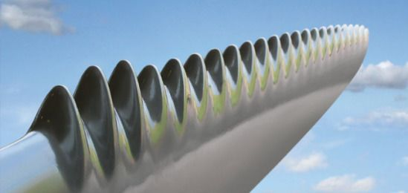

**Figure of wing with tubercles and the other the humpback whale**

However, it's important to note that while the concept is intriguing, the practical implementation and real-world benefits are still being explored and researched. There are challenges in designing and manufacturing turbine blades with tubercles, as well as evaluating their long-term durability and performance.

Additional research and testing are required to fully understand the impact of tubercles on wind turbine efficiency, including factors such as different wind conditions, blade sizes, and turbine configurations. As of my knowledge cutoff in September 2021, the use of tubercles on wind turbines is still an area of ongoing research and development.

The **power coefficient (Cp)** of a wind turbine is typically determined through experimental testing, computational simulations, or by referencing performance curves provided by the wind turbine manufacturer. Here are a few common methods used to find the power coefficient:

1. Experimental testing: Wind turbines are subjected to controlled testing in wind tunnels or under real-world operating conditions to measure their performance. During these tests, various parameters, including wind speed, power output, and rotational speed, are measured and analyzed to calculate the power coefficient.

2. Computational simulations: Computational fluid dynamics (CFD) simulations can be used to model the aerodynamic behavior of wind turbine blades and calculate the power coefficient. By simulating the airflow around the turbine blades and analyzing the resulting forces and power output, the power coefficient can be estimated.

3. Manufacturer data: Wind turbine manufacturers often provide performance curves or specifications for their turbines, including the power coefficient at various wind speeds. These values are typically obtained through testing and validation conducted by the manufacturer.

It's important to note that the power coefficient can vary based on several factors, including wind speed, blade pitch, and operating conditions. Therefore, it is common to refer to performance curves that provide the power coefficient values over a range of wind speeds.

If you are specifically interested in the power coefficient of a particular wind turbine, it is recommended to consult the turbine manufacturer's documentation or reach out to them directly for the most accurate and up-to-date information.

The power supplied to a wind turbine generator can be calculated using the following equation:

***Power = 0.5 * ρ * A * Cp * V^3***

Where:

- Power is the electrical power generated by the wind turbine (in watts or kilowatts).

- ρ (rho) is the air density (in kilograms per cubic meter).

- A is the swept area of the turbine blades (in square meters).

- Cp is the power coefficient, representing the efficiency of the turbine in extracting power from the wind. It is a dimensionless value ranging from 0 to 1, with 1 representing maximum efficiency.

- V is the wind speed (in meters per second).

This equation is derived from the principles of kinetic energy conversion, where the power extracted from the wind is proportional to the cube of the wind speed and is further influenced by the air density, swept area, and efficiency of the turbine.

It's worth noting that the power coefficient (Cp) is specific to the design and characteristics of the wind turbine and can vary based on factors such as the turbine's aerodynamic profile, control systems, and the operating conditions. The Cp value is typically provided by the turbine manufacturer and can be influenced by factors such as wind speed, blade pitch, and generator load.

It's important to use appropriate units for the variables in the equation to ensure accurate calculations.

**DESIGN CONSIDERATIONS**

Design considerations for the integrated wind turbine and solar panel system in a car include:

1. Power Generation: The primary objective is to maximize power generation from both the wind turbine and solar panels. The design should focus on selecting efficient components and optimizing their placement to capture the maximum available wind and solar energy.

2. Aerodynamics: The aerodynamic design of the car plays a crucial role in minimizing drag and maximizing energy efficiency. Streamlined contours, reduced frontal area, and optimized airflow around the wind turbine and solar panels are essential considerations to enhance overall performance.

3. Structural Integrity: The design must ensure the structural integrity of the car while accommodating the added weight and dynamic forces exerted by the wind turbine and solar panels. Proper reinforcement and load distribution are essential to maintain the car's stability, durability, and passenger safety.

4. Integration and Space Utilization: Efficient integration of the wind turbine, solar panels, generator, and other system components within the car's structure is vital. The design should consider the available space, ensuring optimal utilization and minimal impact on the vehicle's functionality, aesthetics, and passenger comfort.

5. Electrical System Integration: The design must accommodate the electrical system required to harness, store, and distribute the generated power. This includes considerations for the electrical connections, wiring, storage batteries, and charging mechanisms to efficiently utilize the generated energy for powering the car and other electrical systems.

6. Maintenance and Serviceability: The design should facilitate easy access for maintenance and service tasks related to the wind turbine, solar panels, generator, and associated components. Considerations for component replacement, troubleshooting, and regular maintenance should be taken into account to ensure long-term reliability and performance.

7. Environmental Impact: Sustainable design principles should be considered to minimize the environmental impact of the system. This includes selecting materials with low carbon footprint, promoting recyclability, and implementing eco-friendly manufacturing and disposal practices.

8. Regulatory Compliance: The design should adhere to applicable regulations and safety standards related to electrical systems, vehicle operation, and renewable energy integration. Compliance with local, national, and international standards ensures the system's legality, safety, and marketability.

By addressing these design considerations, an integrated wind turbine and solar panel system can be developed to maximize energy generation, optimize performance, ensure structural integrity, and comply with relevant regulations and sustainability goals.

**METHODOLOGY**

The methodology for the project involved careful consideration of several key factors, including bearing selection and shaft length, solar panel selection, airfoil selection, and generator election. Each of these components played a crucial role in optimizing the performance and efficiency of the integrated wind turbine and solar panel system.

The methodology aimed to create a well-integrated and optimized system. The selection of appropriate bearings and shaft length, efficient solar panels, suitable airfoil profiles, and a well-matched generator all contributed to maximizing energy production and overall system performance.

**BEARING SELECTION AND SHAFT DESIGN**

For the bearing selection and shaft design, extensive research and analysis were conducted to identify bearings that could withstand the demanding operating conditions of the wind turbine. Factors such as load capacity, durability, and low friction were taken into account to ensure smooth rotation and minimize energy losses. The appropriate shaft length was determined to achieve optimal turbine height and maximize wind capture.

## SKF 6209-2Z Bearing Specification

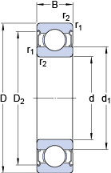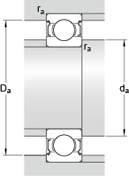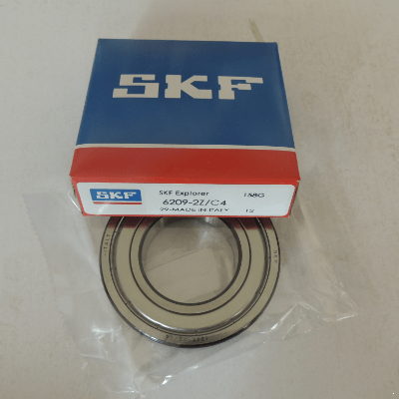

**Shaft Design**

The max shaft length is 800mm

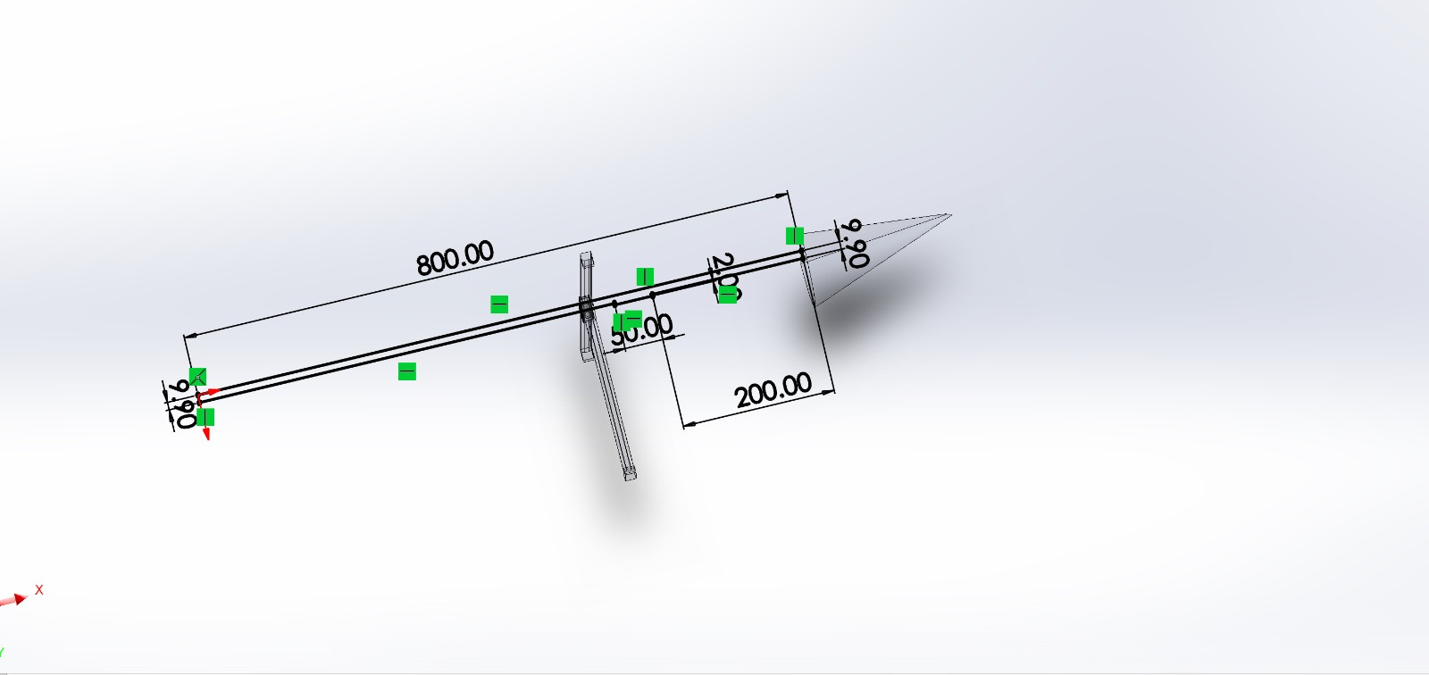

**Figure showing other shaft parameters**

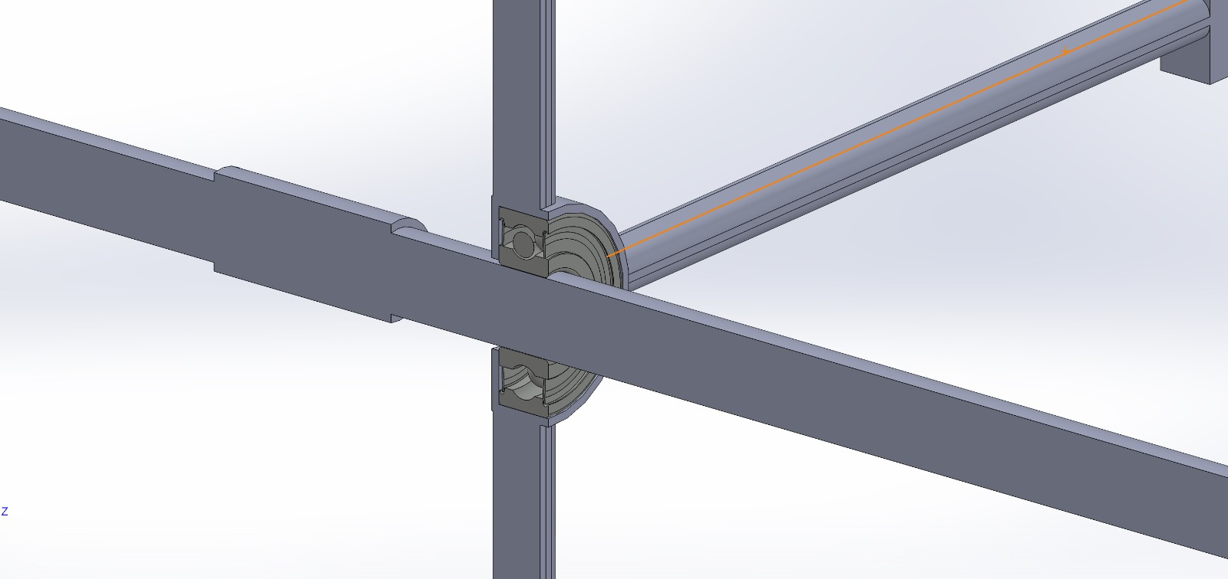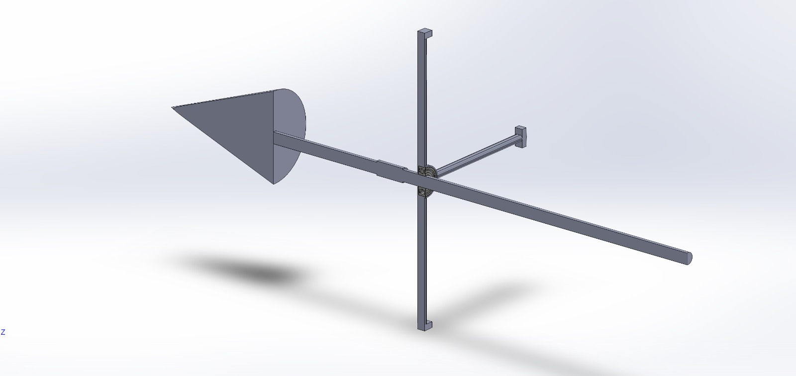

|  |
| --- |
| **Bearing dimensions and specification in CNHK catalogue:** |
| Bearing number : 6209-2Z |
| Size (mm) : 45x85x19 |
| Brand : The brand you need |
| Bore Diameter (mm) : 20 |
| B - 14 mm |
| d1 - - 28.8 mm |
| D2 - - 40.59 mm |
| r1,2 - min. - 1.1 mm |
| da - min. - 25.6 mm |
| da - max. - 28.7 mm |
| Da - max. - 78 mm |
| ra - max. - 1 mm |
| Basic dynamic load rating - C - 13.5 kN |
| Basic static load rating - C0 - 6.65 kN |
| Fatigue load limit - Pu - 0.28 kN |
| Reference speed - 17000 r/min |
| Limiting speed - 8500 r/min |
| Calculation factor - kr - 0.025 |
| Calculation factor - f0 - 14.2 |
| Mass bearing - 0.433 kg |
| Tags :  CNHK , 45x85x19 |

**AIRFOIL AND BLADE SELECTION**

Airfoil selection played a vital role in determining the wind turbine's aerodynamic performance. Extensive computational analysis and wind tunnel testing were conducted to evaluate different airfoil profiles, considering factors such as lift-to-drag ratio, stall characteristics, and turbulence resistance. The chosen airfoil design aimed to maximize energy extraction from the wind while maintaining stable and efficient operation across a wide range of wind speeds.

**parameters**

Name = NACA 2412 Airfoil M=2.0% P=40.0% T=12.0%Chord = 50mm Radius = 0mm Thickness = 100% Origin = 0% Pitch = 0°

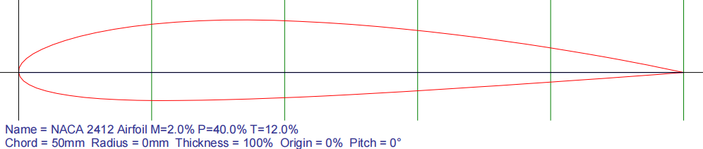**Figure of airfoil used on the turbines**

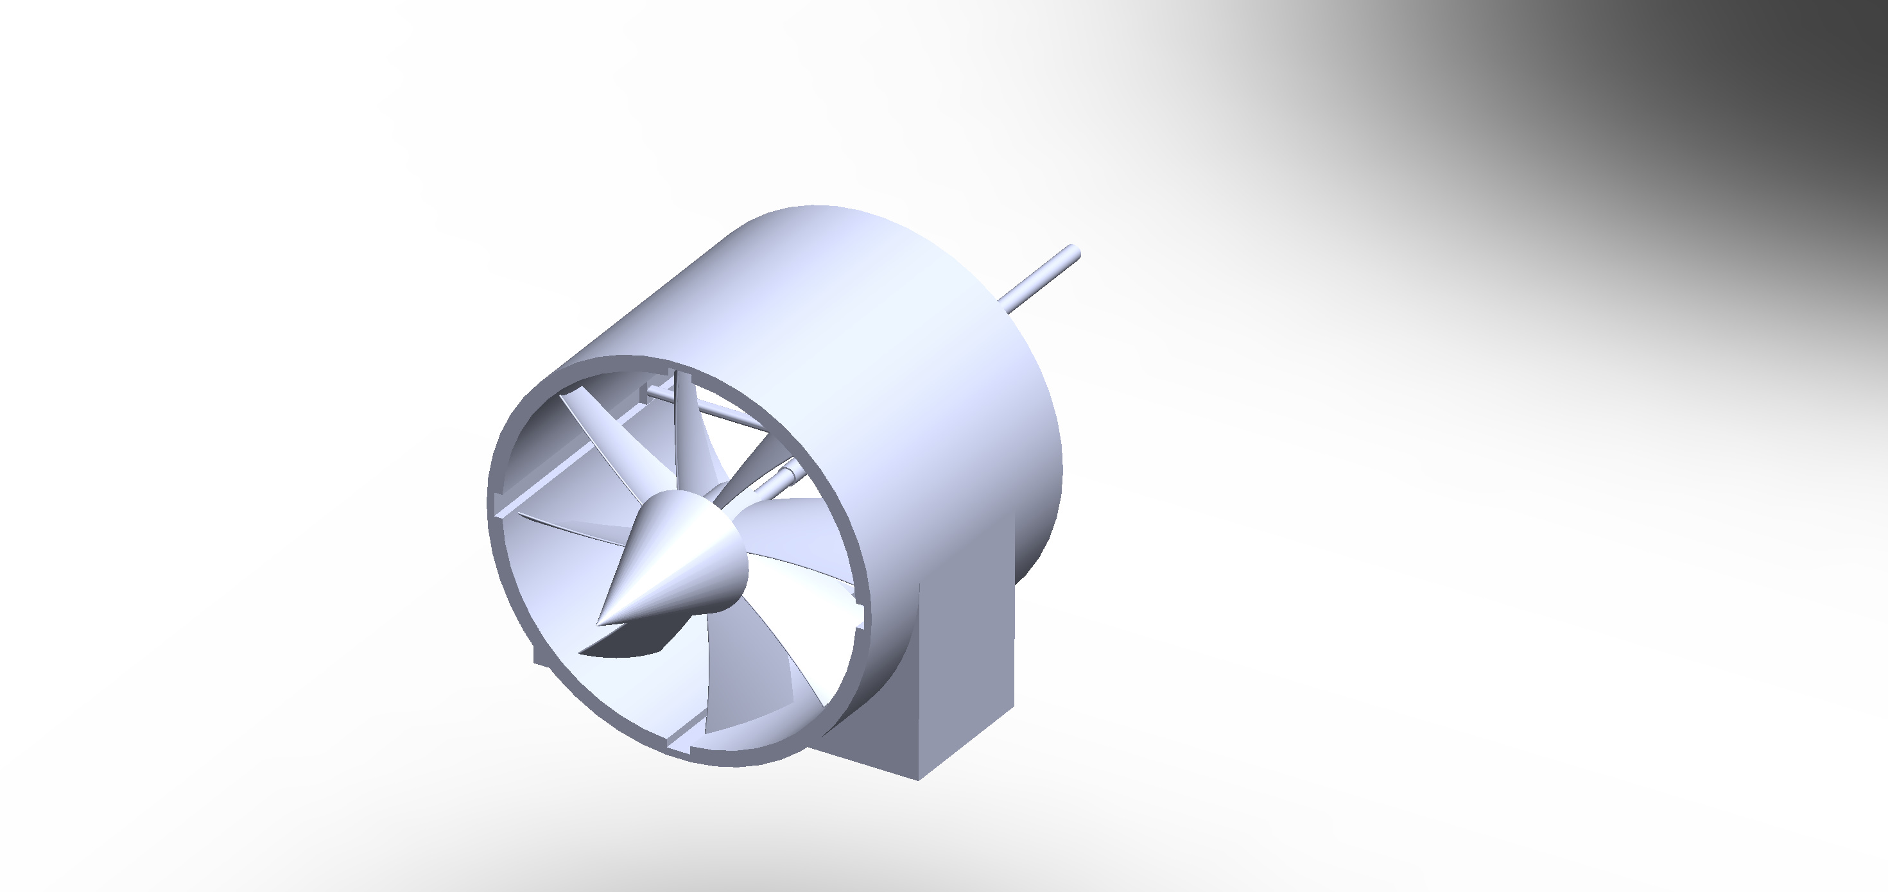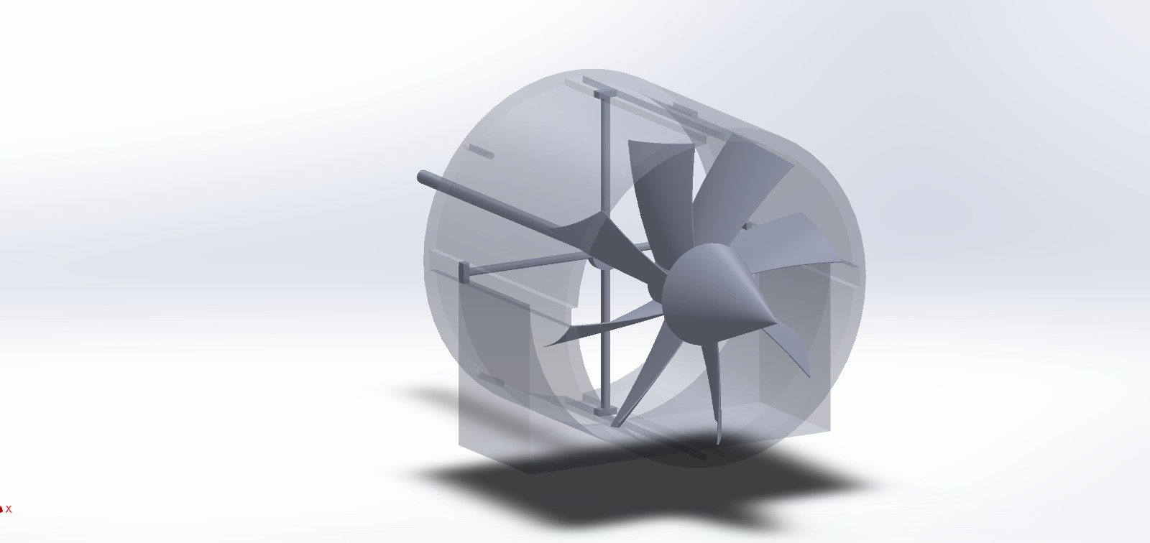

**Figure of the turbine CAD design**

**TYPE OF GENERATOR SELECTED FOR DESIGN**

The generator selection process involved considering various generator types and their suitability for the project's scale and requirements. Factors such as efficiency, power output, and compatibility with the wind turbine and solar panel system were evaluated. The chosen generator was selected to ensure efficient conversion of mechanical energy from the wind turbine into electrical energy, complementing the power generated by the solar panels.

**Paramters:**

|  |  |
| --- | --- |
| **Brand** | NINILADY |
| **Wattage** | 1000 watts |
| **Power Source** | Wind Powered |
| **Output Wattage** | 1000 Watts |
| **Color** | White |
| **Frequency** | 60 Hz |
| **Item Weight** | 18 Kilograms |
| **Voltage** | 48 Volts |
| **Output Wattage** | 1000 Watts |
| **Color** | 48V With Base |
| **Ignition System Type** | magnet |
| **Wattage** | 1000 watts |

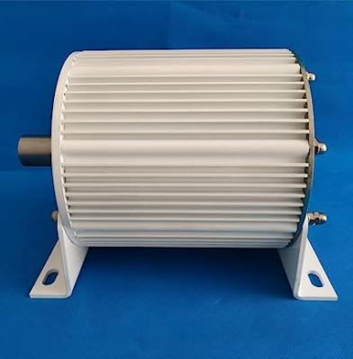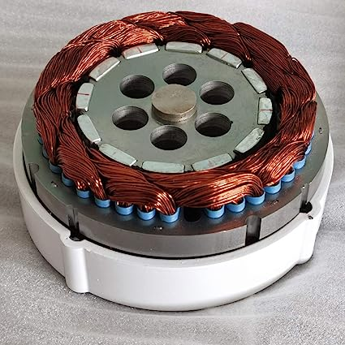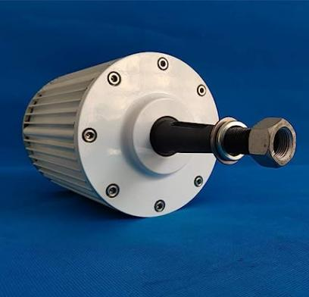

**Figure of the permanent magnet synchronous generator**

**SOLAR PANEL SELECTION**

Regarding solar panel selection, various parameters were considered, including efficiency, durability, and size. The aim was to choose high-efficiency solar panels that could effectively convert sunlight into electrical energy while withstanding environmental factors such as temperature variations and physical stresses.

**Parameters:**

|  |  |
| --- | --- |
| Maximum Rating Power(W) | 100 |
| Open Circuit Voltage(V) | 21.58 |
| Maximum Power Voltage(V) | 18.72 |
| Short Circuit Current(A) | 6.85 |
| Maximum Power Current(A) | 5.87 |
| Module Efficiently(%) | 22 |
| Power Tolerance(%) | 0/+3 |
| Solar Cell | 32 mono 125*125mm |
| Dimensions(mm) | 1065*540*18 |
| Weight | 2.0kg |
| Nominal Operating Temp | 45 ± 2 ºC |
| Series Fuse Rating | 15A |
| Front Materials | Epoxy Fiberglass Board |

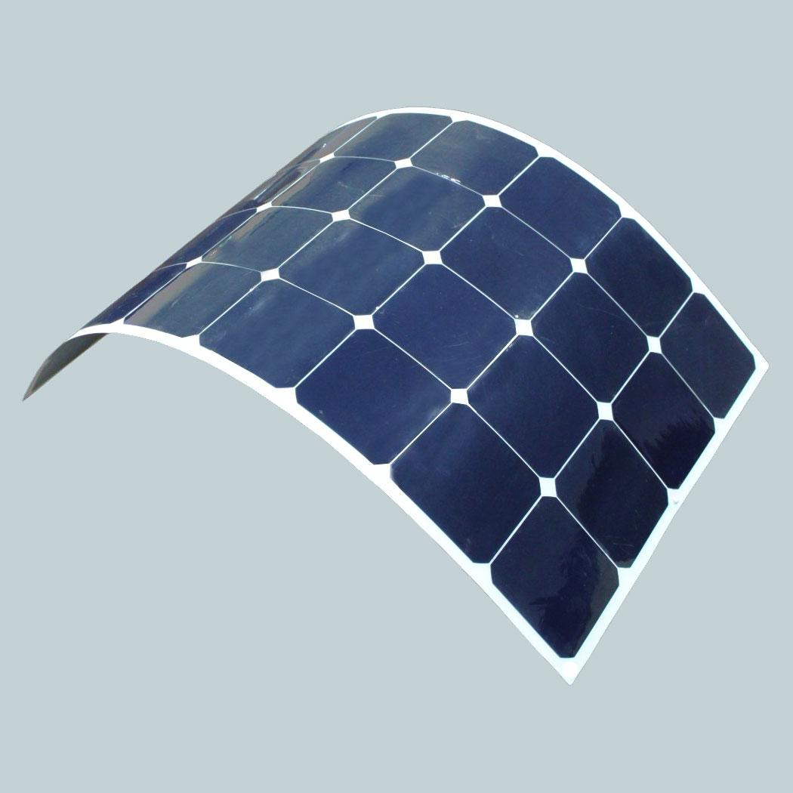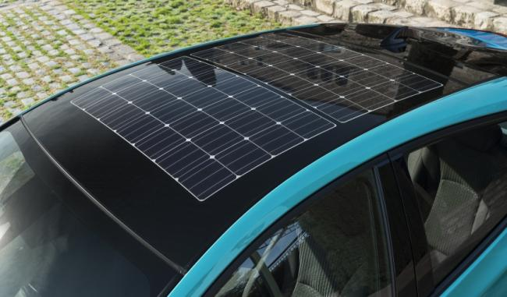

**Figure of a flexible solar panels and solar panels on the car roof**

**SIMULATIONS AND CAD MODELS**

Simulations and CAD models played a crucial role in the design and development process of the car. They were employed to assess the structural integrity, optimize performance, and analyze the airflow characteristics of the vehicle.

Stress analysis simulations were conducted to evaluate the mechanical strength and durability of critical components, such as the chassis, suspension system, and load-bearing structures. By subjecting the CAD models to virtual stress tests, as engineers were able to identify potential weak points, optimize material selection, and ensure that the car could withstand the forces and vibrations encountered during operation.

Through the use of simulations and CAD models, engineers were able to refine the car's design, ensuring structural integrity, optimizing performance, and enhancing aerodynamic efficiency. These virtual tools played a significant role in the development process, allowing for accurate predictions and informed decision-making before physical prototypes were built. The integration of stress analysis, CAD models, and airflow simulations contributed to the successful design and optimization of the car's performance.

**CAD MODEL IN SOLIDWORKS**

CAD models were created to visualize the car's design and enable precise measurements and adjustments. The models allowed for detailed examination of the car's geometry, ensuring proper fit and integration of various components. This facilitated accurate positioning of the wind turbines, solar panels, generator, and other systems within the vehicle.

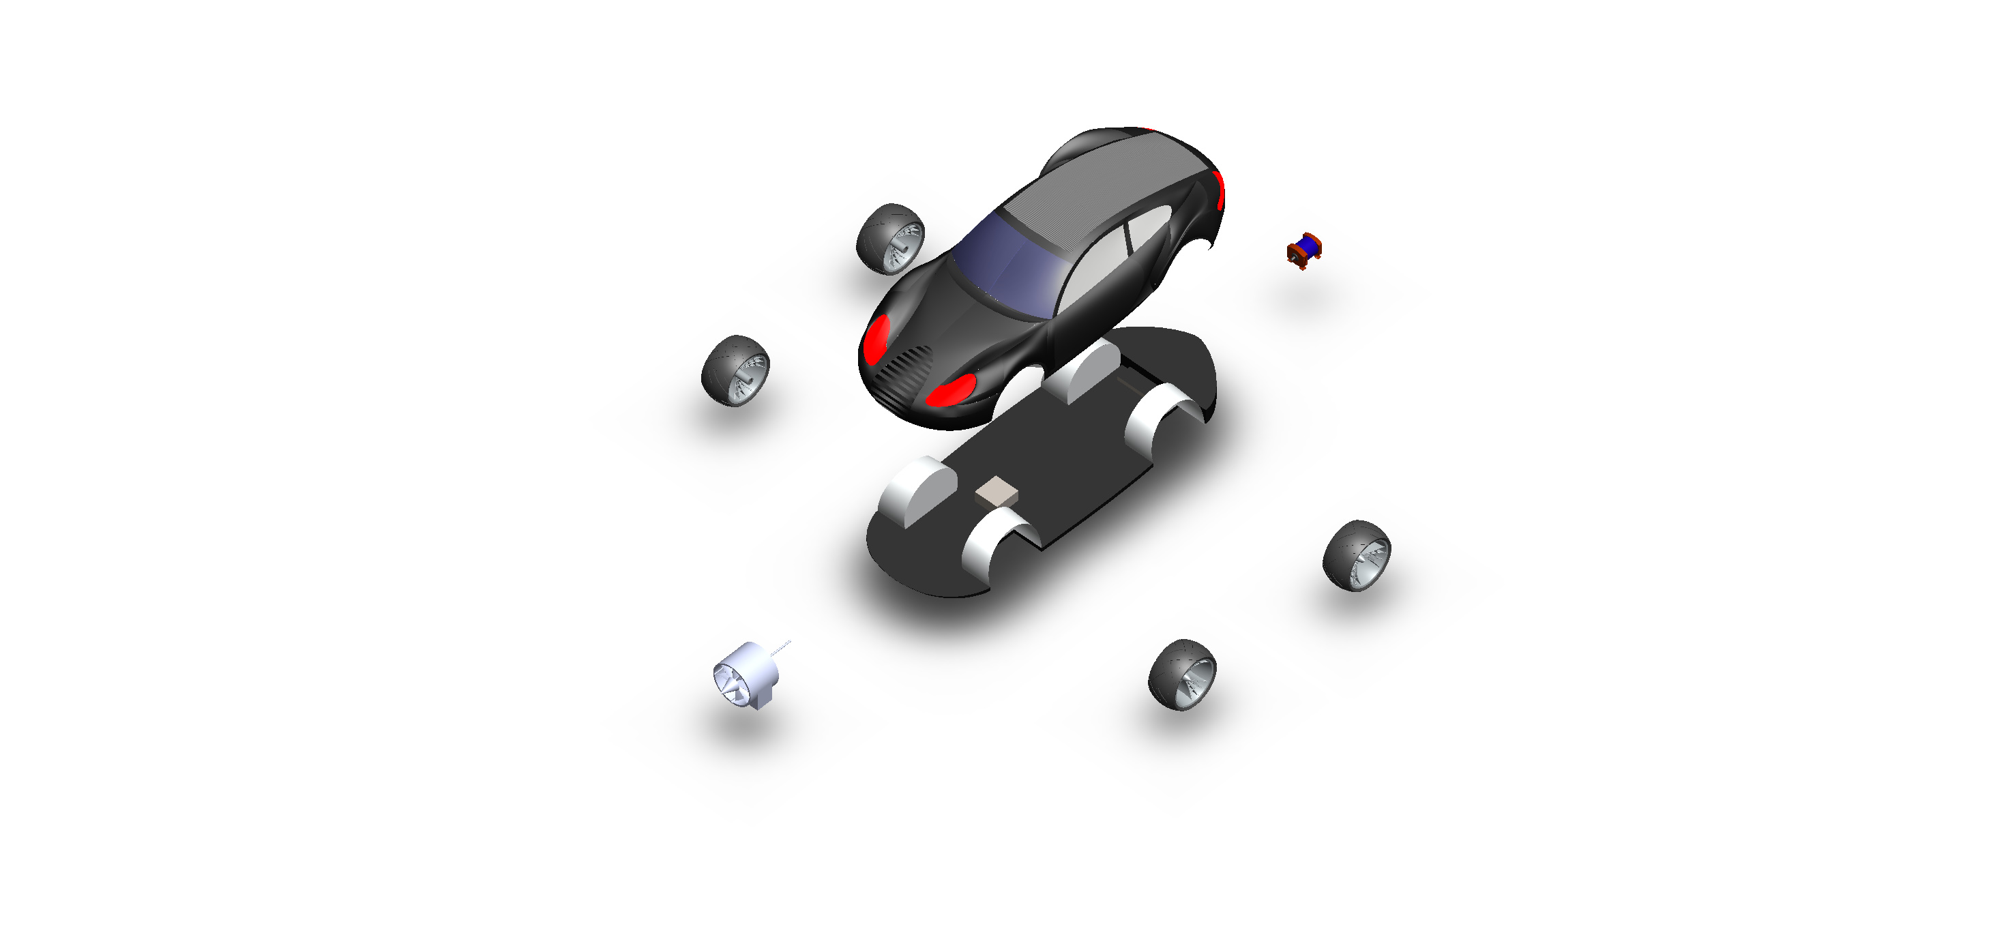

**Figure of explored view Figure of explored view Figure of explored view** 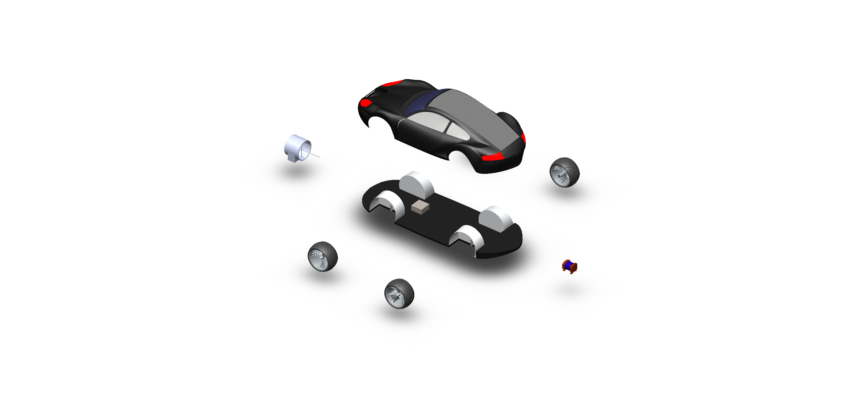

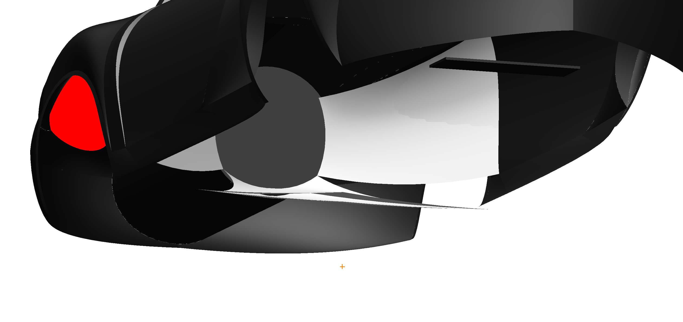

**Figure showing the internal wind tunnels which direct air from front to the sides**

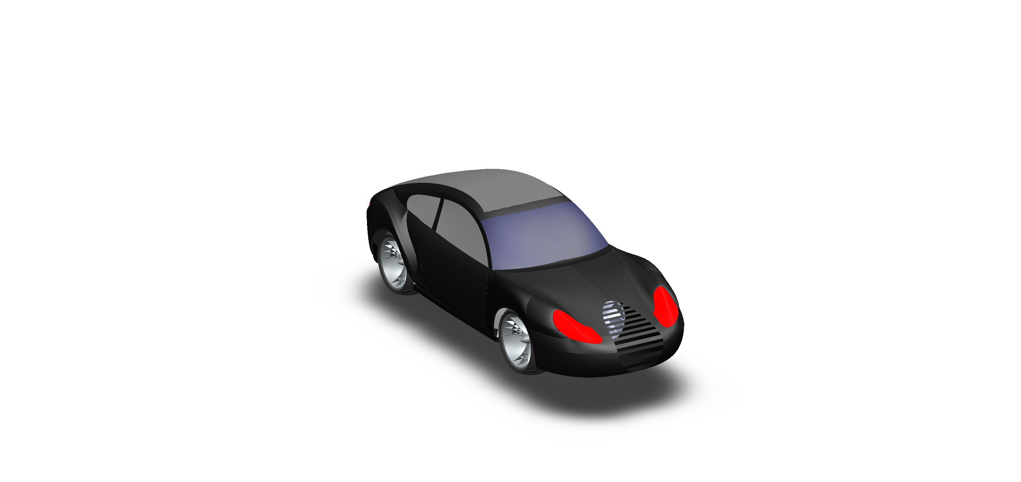

**Figure of the car assembly**

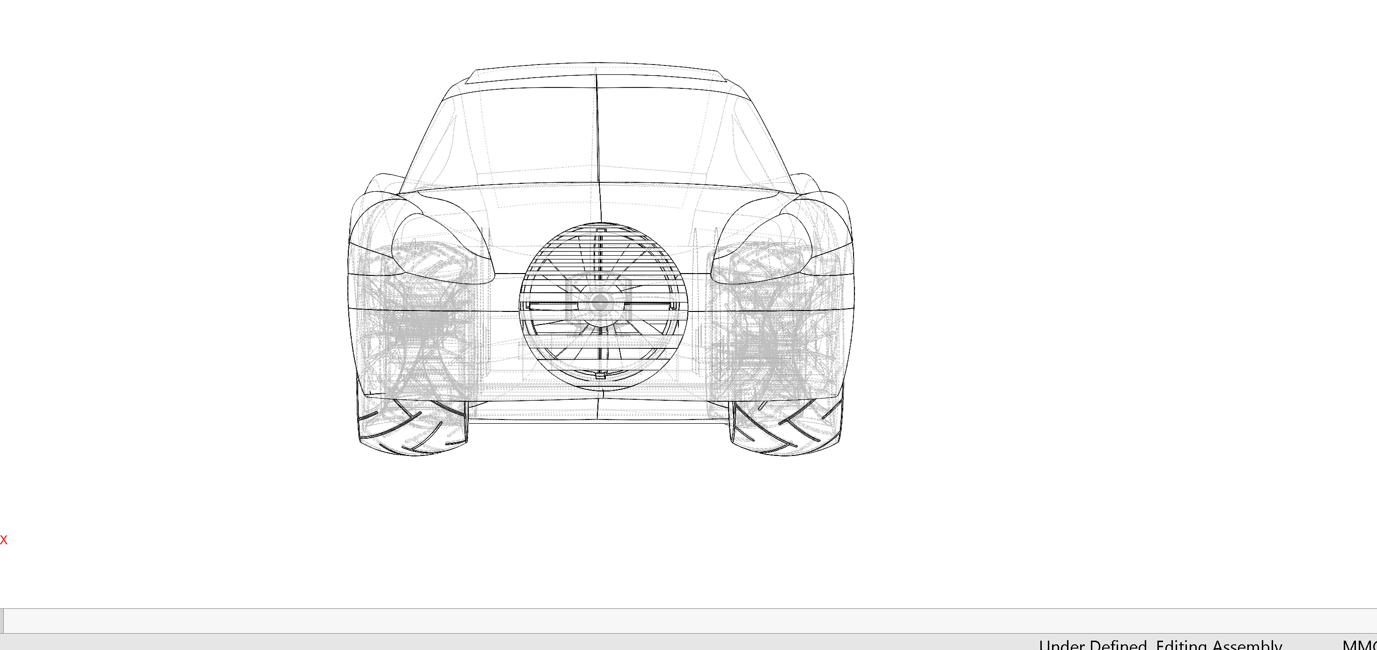

**Figure of front sketch**

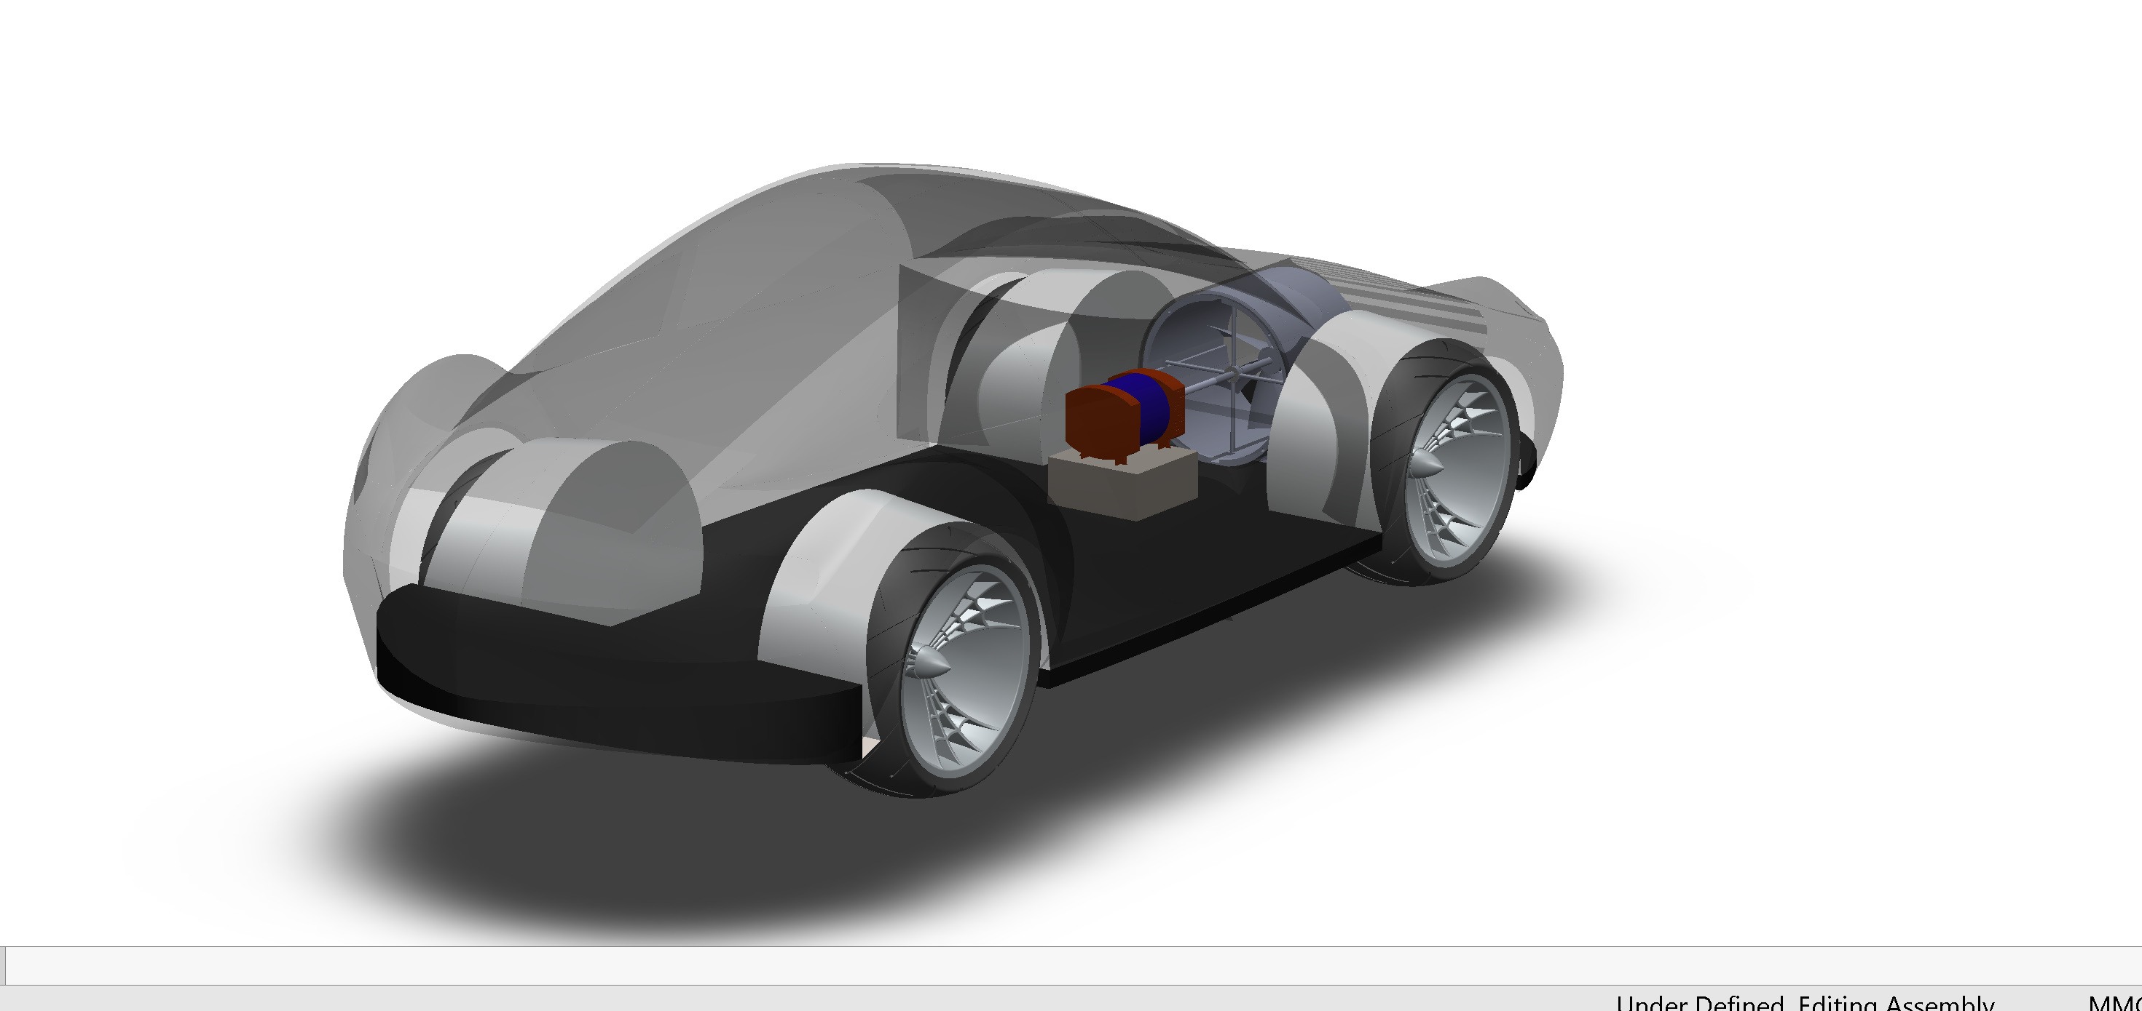

**Figure of the internal view showing the generator to the wind turbines**

**SIDE VIEW ,FRONT VIEW AND BACK VIEW OF THE CAR**

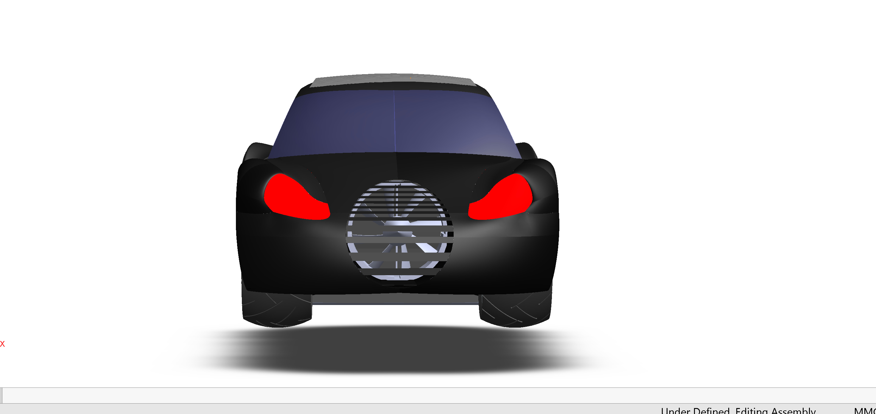

**Figure of front view**

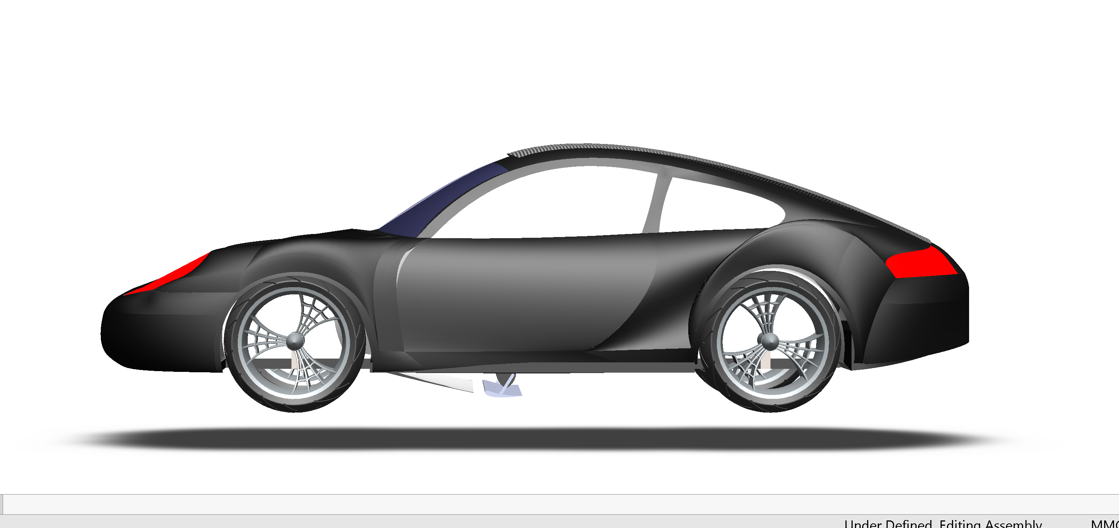

**Figure of the side view**

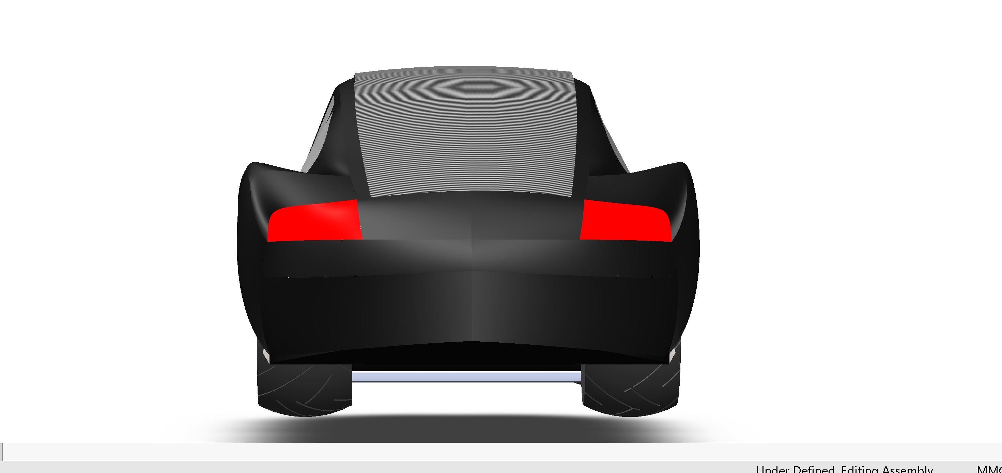

**Figure back view**

**AIRFLOW SIMULATIONS**

Airflow simulations played a crucial role in understanding and optimizing the aerodynamic performance of the car. Computational Fluid Dynamics (CFD) techniques were employed to simulate the airflow patterns around the vehicle, identify areas of high drag, and minimize aerodynamic resistance. By making iterative changes to the car's design based on these simulations, we were able to improve its overall efficiency and reduce energy losses due to air resistance.

**Parameters:**

|  |  |  |  |
| --- | --- | --- | --- |
| **Local Parameter** | **Minimum** | **Maximum** | **Average** |
| Density (Fluid)[kg/m^3] | 1.162144929 | 1.298496058 | 1.192731249 |
| Pressure [Pa] | 98776.5449 | 109666.8686 | 101076.2404 |
| Velocity [m/s] | 4.242536819 | 136.2945258 | 66.12347163 |
| Velocity (X) [m/s] | 0 | 0 | 0 |
| Velocity (Y) [m/s] | -131.78362 | 131.7836197 | 0.000272663 |
| Velocity (Z) [m/s] | -122.724365 | 122.7147768 | -0.01710393 |
| Shear Stress [Pa] | 0 | 18.34534286 | 4.479637917 |
| Shear Stress (X) [Pa] | -11.3150363 | 6.082181493 | -3.62873196 |
| Shear Stress (Y) [Pa] | -14.5254627 | 14.04536752 | -0.07786364 |
| Shear Stress (Z) [Pa] | -17.3696011 | 18.13538761 | 0.07381016 |

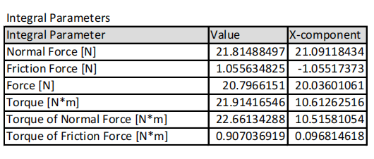

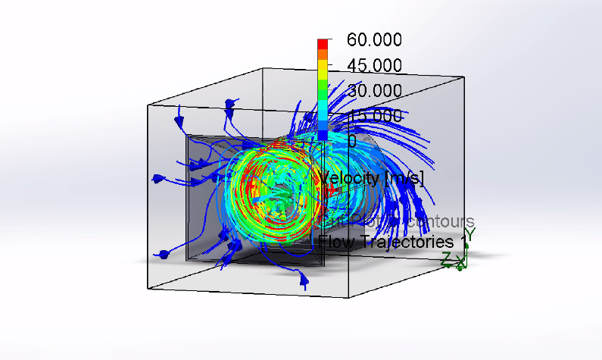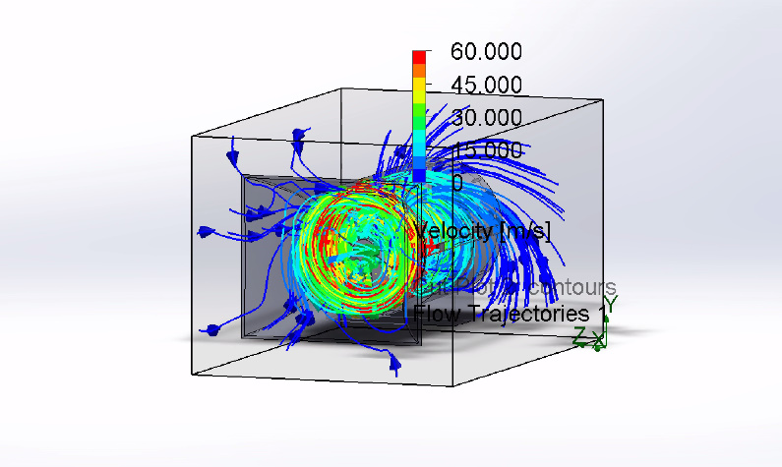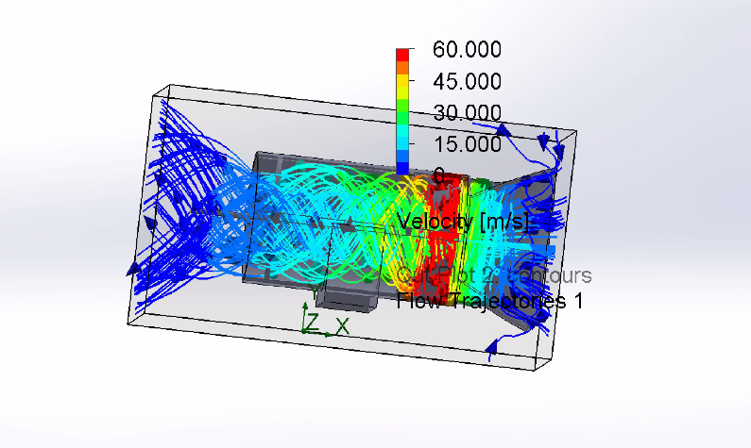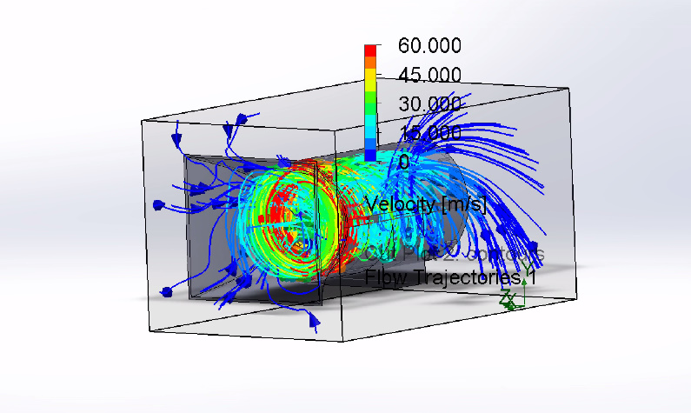

**CALCULATONS**

**Shaft power**

From the simulation the shaft speed was 600 rpm

The torques in the x component was 10.612Nm

P = T* w

P = 10.6126 * 2* 3.142*600/60

P = 666.81 watts

**Wind Power**

The inlet diameter of the turbine assembly is 48cm

Converting centimeters to meters

D = 1m/100cm*48

D = 0.48m

Radius is now 0.24m

**Find the swapping area of the blades**

A = 3.142* r2

A = 3.142*(0.24)^2

A = 0.1809557368m^2

**The density of pure dry air is 1.293kg/m^3 at a temperature of 273K and 101.325KPa**

P = 0.5 *p*A*V^3

**The Average velocity of the wind is 66.123m/s**

P= 0.5*1.293*0.181*66.123^3

P = 33821.9414watts

**Then finally we find the efficiency**

Cp = P’/P = input power/output power

Cp = 666.81/33821.9414

Cp = 0.01971531

**In percentage**

Cp = 1.97%

**CONCLUSION**

In conclusion, the integration of wind turbines, solar panels, and a generator in the car demonstrates a promising approach towards sustainable energy production. Despite the lower efficiency of the turbines, they are still capable of supplying over 600 watts of power to the car's generator. Additionally, the solar cells incorporated into the car's surface contribute an additional 200 watts of power.

When these renewable energy sources are combined, they provide a significant contribution to the overall power generation. The wind turbines take advantage of the available wind resources, while the solar panels harness the sun's energy. This hybrid system ensures a continuous and reliable power supply, making the car more energy-efficient and environmentally friendly.

The combination of wind and solar energy helps to diversify the energy sources, reducing dependence on traditional fossil fuels and mitigating the carbon footprint associated with transportation. This integrated system not only promotes sustainable practices but also serves as an innovative solution to address the global challenge of reducing greenhouse gas emissions.

Furthermore, the ability to generate power from both wind and solar sources enhances the resilience and self-sufficiency of the car. It enables the vehicle to operate even in remote or off-grid areas where conventional power sources may be limited or unavailable.

As renewable energy technologies continue to advance, the efficiency of wind turbines and solar panels is expected to improve, further increasing the overall power output. This progress will contribute to the widespread adoption of clean energy solutions and accelerate the transition towards a more sustainable future.

In conclusion, the integration of wind turbines, solar panels, and a generator in the car presents a viable and promising pathway for sustainable energy production, with the turbines providing over 600 watts and the solar cells contributing an additional 200 watts of power. This hybrid system combines the benefits of both wind and solar energy, promoting energy diversity, reducing environmental impact, and paving the way for a cleaner and greener transportation future.

**REFERENCES**

1. Ladson, C.L., & Brooks, C.W., Jr. (November 1975). "Development of a Computer Program to Obtain Ordinates for the NACA 4-Digit, 4-Digit Modified, 5-Digit, and 16-Series Airfoils." NASA TM X-3284.

2. Ladson, C.L., & Brooks, C.W., Jr. (September 1974). "Development of a Computer Program to Obtain Ordinates for the NACA 6- and 6A-Series Airfoils." NASA TM X-3069.

3. Whitcomb. (August 1974). "Review of NASA Supercritical Airfoils." ICAS Paper 74-10.

4. Harris, C.D. (March 1990). "NASA Supercritical Airfoils." NASA TP 2969.

5. Becker, J.V. (1980). "The High-Speed Airfoil Program." In The High Speed Frontier, NASA SP445.

6. SKF-BEST. (n.d.). SKF 6209-2Z. Retrieved from https://www.skf-best.com/35227-SKF-62092Z.html

1. Airfoil Tools. (n.d.). NACA 4-Digit Airfoil Database. Retrieved from <http://airfoiltools.com/airfoil/naca4digit>
2. Alternative Energy Tutorials. (n.d.). Synchronous Generator. Retrieved from <https://www.alternative-energy-tutorials.com/wind-energy/synchronous-generator.html>

9. Documentation, User Support, and Verification of Wind Turbine and Plant Models (DE-EE0001378), September 2012. [Online]. Available:

<http://www.osti.gov/bridge/servlets/purl/1051403/1051403.pdf.> [Accessed May 2013].

1. NREL. (October 2011). Dynamic Models for Wind Turbines and Wind Power Plants (NREL/SR-5500-52780). [Online]. Available: <http://www.nrel.gov/docs/fy12osti/52780.pdf>[Accessed February 2013].